Logo & Company Name
System/Software Requirements Specification
for
<Vietnamese Medicinal Network>
Version 1.0 approved
Prepared by <QuynhHT>
<VMN Team>
<Jan-18-2016>
Table of Contents
Table of Contents ii
Revision History iii
1. Introduction 1
1.1 Purpose 1
1.2 System Purpose 1
1.3 Definitions, Acronyms and Abbreviations 1
1.4 Document Conventions 2
1.5 Intended Audience and Reading Suggestions 2
1.6 Project Scope 2
1.7 References 3
2. Overall Description 3
2.1 Product/System Perspective 3
2.2 Use Case Diagram 4
2.3 System Features 5
2.4 Entity Relation Model 7
2.4.1 Entity-Relationship Diagram 7
2.4.2 Entity Detail 7
2.5 Member Classes and Characteristics 10
2.6 Member Documentation 11
3. Specific Requirements 11
3.1 Functional Requirements Specification 11
3.1.1 Authentication functions 11
3.1.2 Article functions 19
3.2 Non-Functional Requirements Specification 27
3.2.1 External Interface Requirements 27
3.2.2 Other Nonfunctional Requirements 27

Revision History
Name | Date | Reason For Changes | Version
Introduction | Jan-18-2016 | 1st creation | 1.0

Introduction

Purpose
The document is aiming at describing detailed specification of functionalities and non-functional requirement of VMN software. It provides detailed information for developers, testers, project manager, managers, supporters and VMN users to have full understanding about VMN software what functionalities, development, and operational constraints the software must have.

By using this document, project team, business support team and the other people can have an overview about the software requirement specification of the VMN application and business/power users can review this document to know how the requirements have been documented. This document also describes the requirement scope of each phase in the project, users can verify the software to make sure the being provided software meet their expectation.

System Purpose
VMN will provides the information about medicinal plants and remedies. Members can search these information that they need. They also can share their experiences and comment or rate useful articles. Eastern drug store can create their remedies article, share address to other members. When problems happen, mod will send message to members. VMN also provides functionalities for mod to manage articles about medicinal plants and remedies such as approve, view, create, update, delete articles; admin to manage member’s account.

Definitions, Acronyms and Abbreviations
The document use the following terms, concepts, and acronyms defined in the table 1-1:

Table 1-1: Definitions, Acronyms and abbreviations
# | Concept, term, abbreviations | Description
1 | Guest | Anyone who have not register in VMN system.
2 | Member | Person who register success in VMN system include mod, herbal medicine store and common member.
3 | HMS | Herbal medicine store.  Person who register success in VMN system and is approved as Vietnamese herbal medicinal store by admin.
4 | Mod | Person who register success in VMN system and their account is approved by admin that they can manage articles.
5 | Admin | System administrator who can manage members and authorize other accounts.
6 | Medicinal plants | System object that member can search, comment and rate. Medicinal plants are plants that have utility for treat disease.
7 | Remedy | System object that member can create, search, comment and rate; mod can manage.  Remedy is set of medicine plants that use for treat disease.
8 | Article | Means that medicinal plants articles or remedy articles
9 | VMN | Vietnamese Medicinal Network

Document Conventions
In this documents, there are the following conventions applied in requirements statements.
- Bold with green background color statement: It means that these requirements are very important, high priority which the readers should read carefully.
- The statement with Italic ad beginning: it means the requirements should have further clarification.

Intended Audience and Reading Suggestions
The document are aiming at the following intended audiences. The readers should consider the suggestion below:
  - Developers should study all sections of this documents to have understanding about the VMN. However, the section 3: Specific Requirements should be more focused to have deep understand functional and non-functional requirements.
  - Testers: should study all sections of this documents to have understanding about the VMN. However, the section 2.3: System Features should be more focused to have deep understand functional requirements.
  - Project manages: should study all sections of this documents to have understanding about the VMN. The section 1.6 Project Scope should be more focused on corporate goals or business strategies
  - Supervisor should study all sections of this documents to have understanding about the VMN in case users need to support.

Project Scope
VMN is built to provide useful information about medicinal plants and remedies to members. MMS project will implements all the states of the software development lifecycle, from requirements analysis, to operation maintenance phase. This version of software being developed from the project will have all functionalities and all operational in this document.

References
The requirements have gathered, analysis, and specified basing on the following sources defined in table 1-2:

Table 1-2: References
# | Source | Description
1 | http://cms.fpt.edu.vn/ | Template_System_Requirement_  Spec (IEEE830 v1.3.doc)
2 | Textbook “Requirements Engineering - From System Goals to UML models to Software Specifications” - Author: Axel van Lamsweerde.

Overall Description

Product/System Perspective

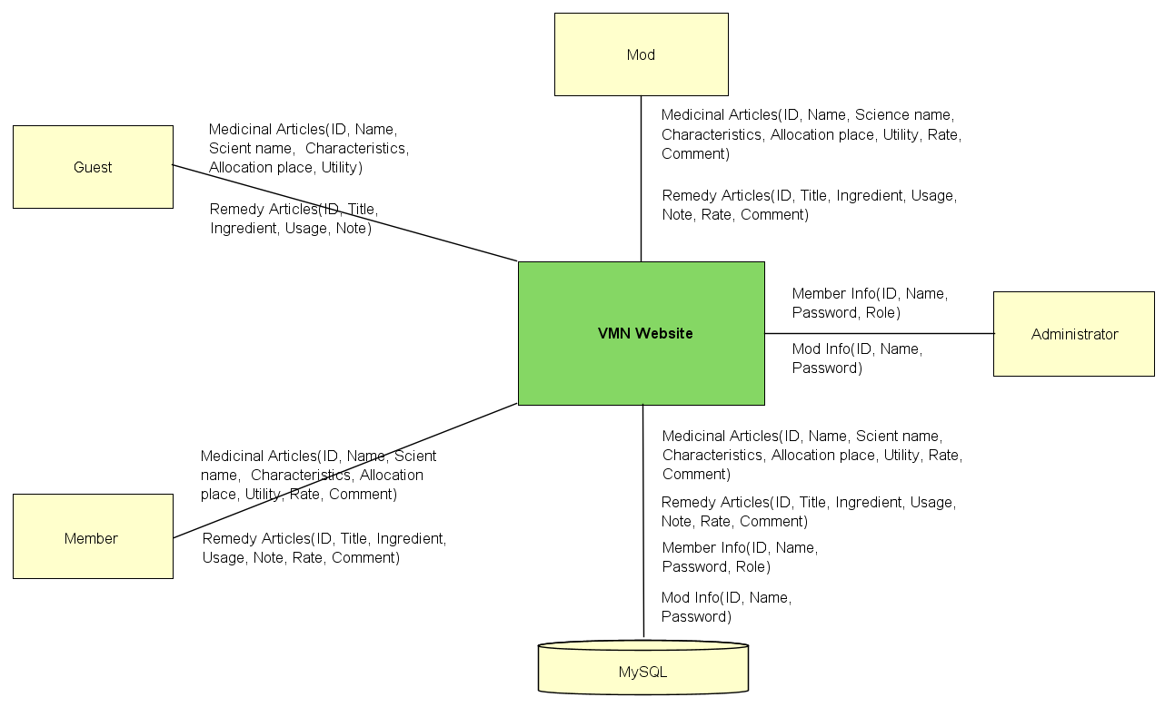

Figure 2-1: System Overview

As described in Figure 2-1, VMN system will has main components: VMN website, Administrator,
Mod, Guest, Member and MySQL.
- VMN website: this is software component to be developed in the project. It will provide functions for mod to manage medicinal plants, remedy articles; member to view, search, create, update their articles, comment and rate other articles; guest to view articles; admin to manage accounts.
- Administrator: they can manage and authorize accounts, also run system.
- Mod: they can manage articles, approve member’s article, create and update their articles, manage member’s comments, send
- Guest: is people who can view and basic search medicinal plants and remedy articles.
- Member: person who register success in VMN. They have ability to view and search, rate and comment other articles, create, update their articles, send messages to mod.

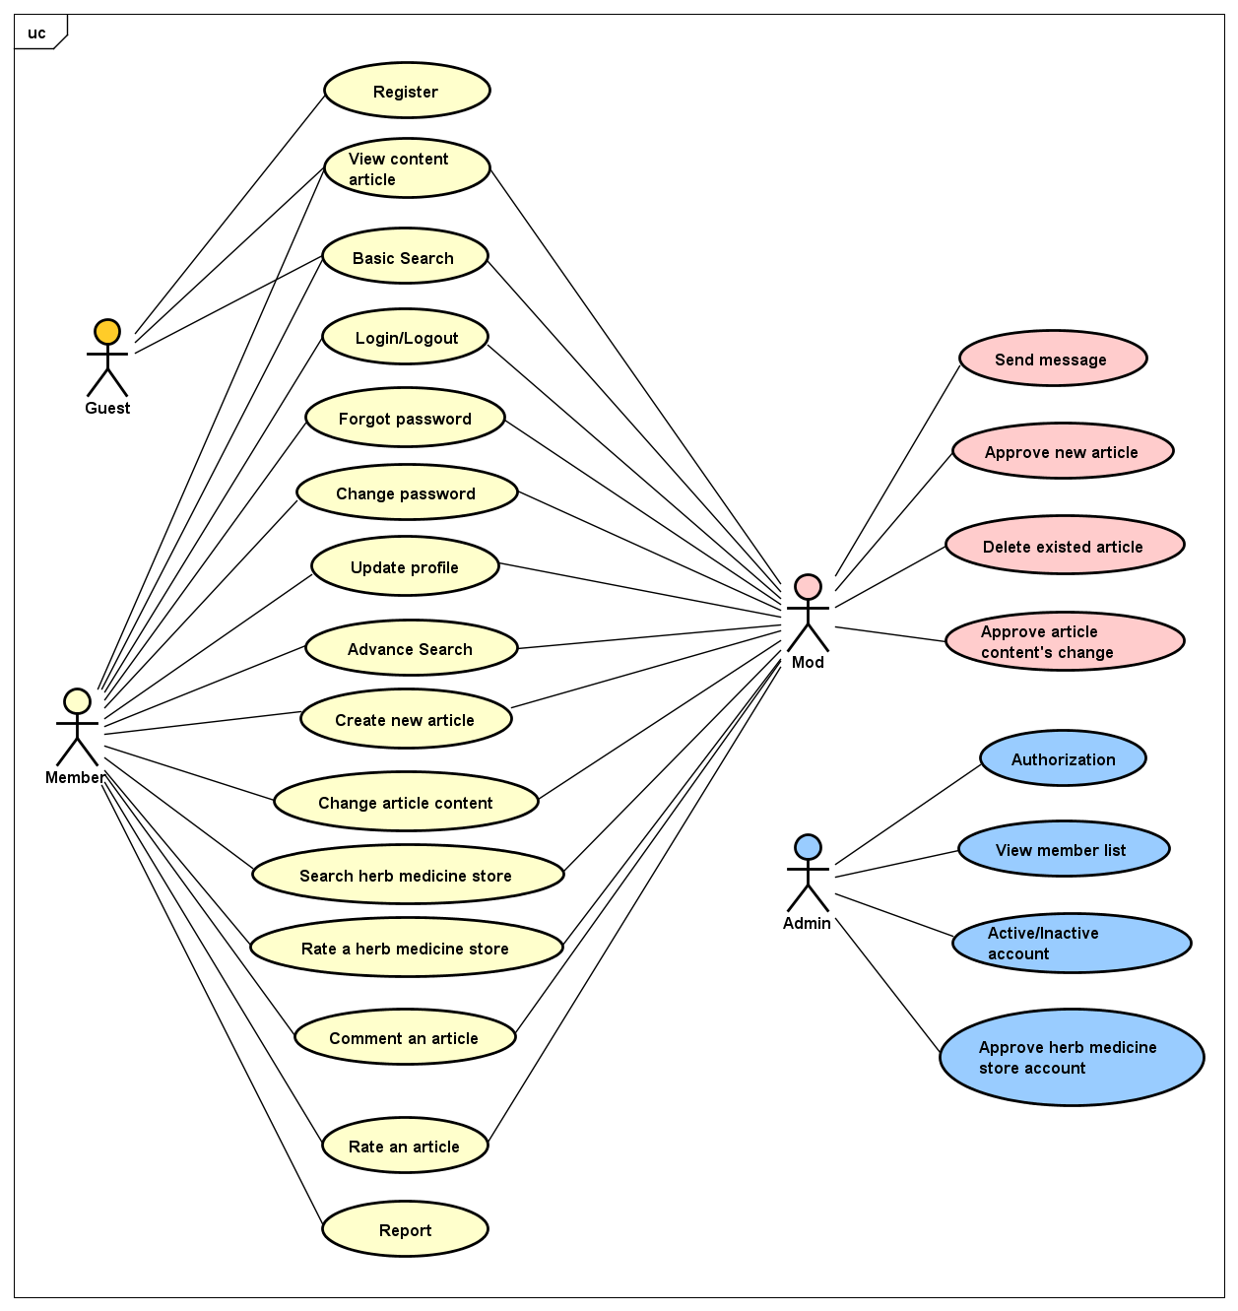
Use Case Diagram

Figure 2-2: Use case diagram of VMN system

System Features

# | Functional group | Use case ID | Function Name | Description
1 | Authentication | UC101 | Login
1 | Authentication | UC102 | Logout
1 | Authentication | UC103 | Authorization | Admin has ability to grant access right for members. For example: a member want to be a mod, he/she need to wait admin’s approving.
2 | Article  functions | UC201 | View article content | Guest, Member and Mod can view content an article.
2 | Article  functions | UC202 | Create | Member, mod has ability to create new article by basic information such as: name, science name, characteristic, allocation place, utility with medicinal plant article or title, ingredients, usage, utility, note with remedy article.
2 | Article  functions | UC203 | Basic Search | Guest, member, mod has ability to search medicinal plant articles or remedy article by name.
2 | Article  functions | UC204 | Advance Search | Member and mod have ability to search a articles by multiple conditions include: characteristic, utility, allocation place.
2 | Article  functions | UC205 | Change content | Member and mod have ability to update their articles to edit, fix information if need. But if members want to update their articles, they need to wait mod’s approving.
2 | Article  functions | UC206 | Delete existed article | Mod has ability to delete duplicate medicinal plant articles. Then mod has to send notice message to author.
2 | Article  functions | UC207 | Rate | Member and mod have ability to rate articles by hover on rate box.
2 | Article  functions | UC208 | Comment | Member and mod have ability to create new remedy article by basic information such as: title, ingredients, usage, utility, note.
2 | Article  functions | UC209 | Approve new article | Mod has ability to approve a new article which is wrote by members.
2 | Article  functions | UC210 | Approve article content’s change | After members change their article contents, they have to wait mod’s approving.
 |  | UC211 | Report | Member has ability to report to mod that existing duplicate or wrong information article.
3 | Member functions | UC301 | View members list | Admin has ability to view list of members include member’s information such as: account, name, email, date of birth, phone, register date, job, avatar, member’s role.
3 | Member functions | UC302 | Inactive/active account | Admin has ability to inactive or active an account.
3 | Member functions | UC303 | Send message | Mod has ability to send messages to member if need. For example: when duplicate of articles happens, mod will delete one article and he/she will send a notice message to the article’s author.
3 | Member functions | UC304 | Update profile | Member, mod and herbal medicine store have ability to update their profile such as name, email, date of birth, phone, register date, job, avatar, address.
3 | Member functions | UC305 | Change password | Member and mod have ability to change their password if they think that it’s not safe anymore.
4 | Guest functions | UC401 | Register | Guest has ability to create an account to become system’s member.
5 | Herbal medicine store | UC501 | Search herbal medicine store | Member and mod have ability to search information of herbal medicine store such as: address, description, email, phone.
5 | Herbal medicine store | UC502 | Rate herbal medicine store | Member and mod have ability to rate a herbal medicine store by hover on rate box.
5 | Herbal medicine store | UC503 | Approve herbal medicine store account | When a guest register as a herbal medicine store account, the guest has to wait admin’s approving.

Entity Relation Model

Entity-Relationship Diagram

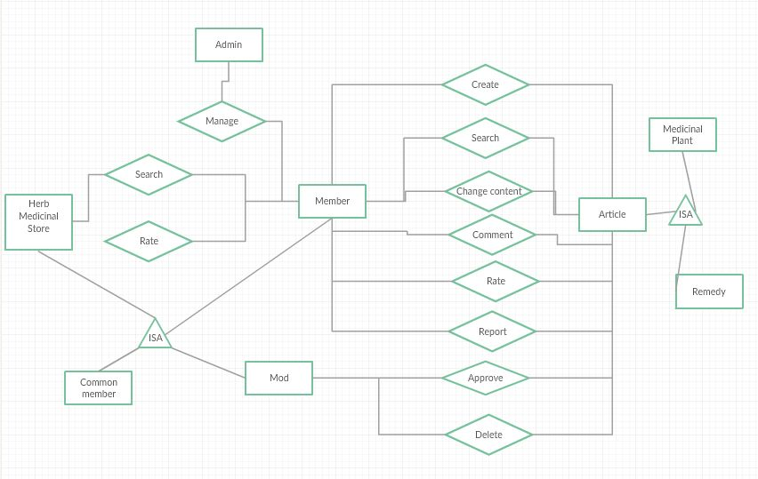
Figure 2-3: Entity- Relationship Diagram of VMN system

Entity Detail

Mod and Member
No | Attribute | Type | Mandatory | Description
 | MemberID | Int | Y | Member’s ID
 | DisplayName | String | Y | Member’s display name
 | Birthday | Date | N | Member’s birthday
 | IsActive | Boolean | Y | Member’s active status (inactive, active)
 | CreatedDate | Date | Y | Member’s created date
 | Avatar | Img | N | Member’s avatar
 | LastLogin | Date | Y | Member’s last login
 | Gender | Boolean | N | Member’s Gender
 | Role | String | Y | Member’s Role (Mod or common member)
 | Email | String | Y | Member’s email
 | First name | String | N | Member’s First name
 | Last name | String | N | Member’s last name

Herb Medicine Store (Store)
No | Attribute | Type | Mandatory | Description
 | MemberID | Int | Y | Store’s ID
 | DisplayName | String | Y | Store’s display name
 | Addresss | String | Y | Store’s address
 | IsActive | Boolean | Y | Store’s active status (inactive, active)
 | CreatedDate | Date | Y | Store’s created date
 | Avatar | Img | N | Store’s image
 | LastLogin | Date | Y | Store’s last login
 | Phone number | String | Y | Store’s phone number
 | Email | Boolean | Y | Email of store account
 | Representative | String | Y | Store’s representative

Medicinal plant (plant)
No | Attribute | Type | Mandatory | Description
 | PlantID | Int | Y | Plant’s ID
 | Name | String | Y | Plant’s name
 | Other name | String | Y | Plant’s other name
 | scientific name | String | N | scientific name
 | Characteristic | String | Y | Plant’s characteristic
 | Image | String | N | Plant’s image
 | Location | String | Y | The places where medicinal plants grow.
 | Usage | String | Y | Plant’s is used for
 | Author | String | Y | Member who provide information about plant
 | Rating point | Int | N | Average point that member rate

Remedy
No | Attribute | Type | Mandatory | Description
 | RemedyID | Int | Y | Remedy’s ID
 | Title | String | Y | Remedy’s title
 | Ingredients | String | Y | What remedy made of
 | Note | String | N | Warning who should not use
 | Usage | String | Y | How to use this remedy
 | Utility | String | Y | the ​usefulness of remedy
 | Author | String | N | Member who provide information
 | Rating point | Int | N | Average point that member rate

Admin

A person have permission to manage all member in system.

Member Classes and Characteristics
VMN website towards to anyone who want to learn and share experiences about medicinal plants and useful remedies. VMN has four objective Member:
- Guest: the person who has ability to view medicinal plants and remedy articles, register to become VMN website’s member, then they can use more and more VMN website’s features. This Member group no need to have good computer and software skill.
- Member: the person who register to VMN website successful. They can use more VMN website’s features than guest such as: advance search, create and change content their articles, search herbal medicine store, comment and rate an article, update profile. This Member group no need to have good computer and software skill but they also understand VMN website more than guest.
- Herbal medicine store: as a member, herbal medicine store has ability to create and change content, share their experiences about high value medicinal plants or useful remedies. They also has ability to share information about their herbal medicine store such as phone, email, address to members as advertising information. This Member group no need to have good computer and software skill but they also understand VMN website.
- Mod: the person who register to VMN website successful and be granted by admin as who has ability to approve member’s article, send notice message to members, comment and rate an article. This Member group should not only have good computer and software skill and deep understand about VMN website, but also have knowledge about medicinal plants and remedy.
- Admin: the person has ability to manage member’s account, approve a herbal medicine store account, and authorization. Other case, they also can active and inactive an account when they detect infraction. This Member group have good computer and software skill and deep understand about VMN website.

Member Documentation
Table 2-2: Member Documentation
Name | Description
Member Guide | Provide detailed explanation about our system, screens and guide Members how to use all feature of VMN system.

Specific Requirements

Functional Requirements Specification

Authentication functions

UC101-Login

Screen Design

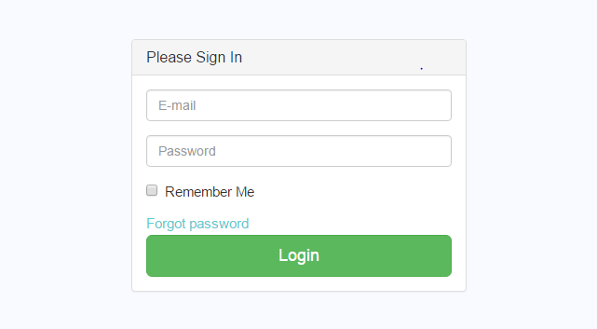

Figure 3-4: Screen design of Login

Table 3-3: Screen Definition
# | Field Name | Type | Mandatory | Max Length | Description
1 | Email | Text | Yes | 20
2 | Password | Text | Yes | 20 | Display "*" instead of clear character
3 | Remember Me | Check box | No
4 | Forgot password | Link | No
5 | Login | Button

Use Case Specification
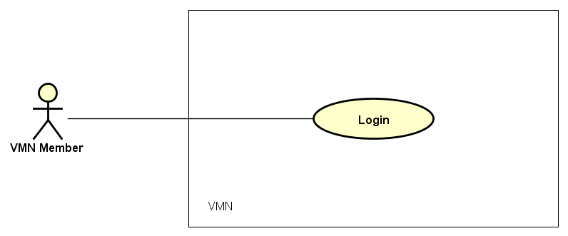

Figure 3-5: Login use case diagram

Use Case ID |  | UC101 | Use Case Name |  | Login
Author |  | QuynhHT | Version | 1.0 | Date | 19/01/2016
Actor |  | VMN Member
Description |  | The function allows a Member to be able to login in the software when he/she have registered an account and his/her account is still active.
Precondition |  | - VMN must be connected to the Internet
Trigger
Post-Condition
Main flows
Step | Actor | Action
1 | Member | Type URL into location field of internet browser and then press enter
2 | VMN | Display Login screen with the following fields:  - Email  - Password  - Remember Me  - Forgot password  - Login button
3 | Member | Enter Email & password into Email & Password fields on the Login screen, then click on Login button.
4 | VMN | Validate the entered Email & password and then display Home screen

Alternative flows
AT1 | At step 2 in the main flows, if there is an internal error in the system,
Sub step | Actor | Action
2.1 | VMN | Display "Error" page with message "Internal System Error, please contact with administrator"
AT2 | At step 4 in the main flows, if VMN failed to validate Member name & password
Sub step | Actor | Action
4.1 | VMN | Display "Login" page with message “The email and password that you entered don’t match.”

Business Rules
# | Rule Description
BR01
BR02

UC102-Logout

Screen Design

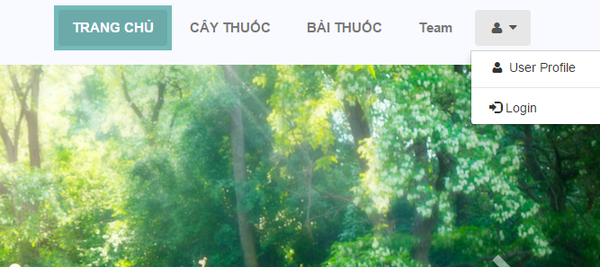
Figure 3-6: Screen design of Logout

Table 3-4: Screen Definition
# | Field Name | Type | Mandatory | Max Length | Description
1 | Member Profile | Button | Yes
2 | Logout | Button | Yes

Use Case Specification

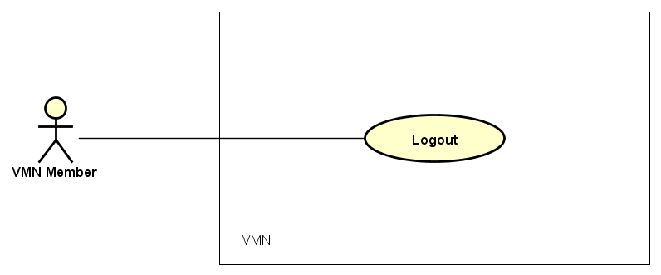

Figure 3-7: Logout use case diagram

Use Case ID |  | UC102 | Use Case Name |  | Logout
Author |  | QuynhHT | Version | 1.0 | Date | 19/01/2016
Actor |  | VMN Member
Description |  | The function allows a Member to be able to logout the website when he/she have registered an account and his/her account is still active.
Precondition |  | - VMN must be connected to the Internet  - Member browsed VMN website  - Member logged in to system
Trigger
Post-Condition |  | - Log Member out from system.  - Redirect Member to login page
Main flows
Step | Actor | Action
1 | Member | Click on “Member” icon
2 | VMN | Display Logout screen with the following fields:  - Member Profile  - Log out button
3 | Member | Click on “Logout” button
4 | VMN | Log out Member account then display Login screen

Alternative flows
AT1 | At step 2 in the main flows, if there is an internal error in the system,
Sub step | Actor | Action
2.1 | VMN | Display "Error" page with message "Internal System Error, please contact with administrator"

Business Rules
# | Rule Description
BR01
BR02

UC103-Authoration

Screen Design

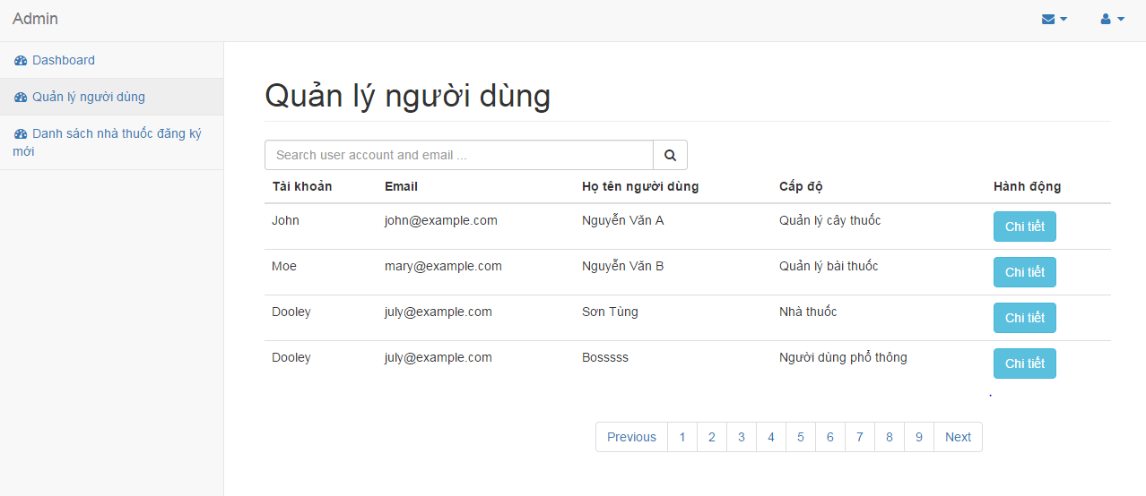
Figure 3-8 Screen design of Manage member

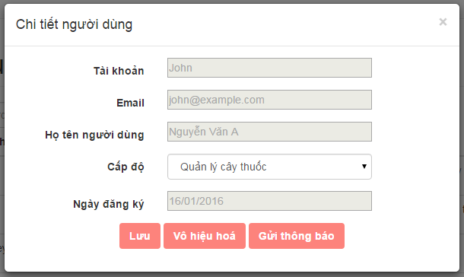
Figure 3-9: Screen design of Member detail

Table 3-5: Screen Definition
# | Field Name | Type | Mandatory | Max Length | Description
1 | Account | Text | Yes | 20 | Admin cannot edit this information.
2 | Email | Text | Yes | 20 | Admin cannot edit this information.
3 | Member’s name | Text | Yes | 20 | Admin cannot edit this information.
4 | Member’s role | Drop box | Yes |  | Admin has ability to change member’s role: member becomes mod, mod becomes member. If member’s role is HMS, admin cannot change.
5 | Date of register | Date | Yes |  | Admin cannot edit this information.
6 | Save | Button | Yes |  | After change, admin has to click on this button to update database.
7 | Send message | Button | Yes |  | Admin will send a message to member who have been changed about member’s role

Use Case Specification

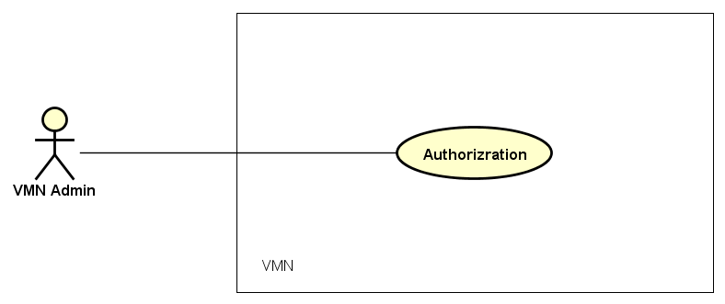
Figure 3-10: Authorization use case diagram

Use Case ID |  | UC103 | Use Case Name |  | Authorization
Author |  | QuynhHT | Version | 1.0 | Date | 19/01/2016
Actor |  | VMN Member
Description |  | The function allows a Member to be able to logout the website when he/she have registered an account and his/her account is still active.
Precondition |  | Admin
Trigger |  | The function allows admin to change member’s role: member becomes mod, and mod becomes member.
Post-Condition |  | - VMN is connected to Internet  - Admin login to VMN website successful
Main flows
Step | Actor | Action
1 | Admin | On admin’s screen, click on “Manage Member” tab.
2 | VMN | Display “Manage Member” screen:  - “Search Member account and email” text field  - “Detail information of member” table:  - Account  - Email  - Member’s name  - Member’s role  - Action  - Paging
3 | Admin | Click on “Detail” button of “Detail information of member” table
4 | VMN | Display “Detail Member” modal screen:  - Account  - Email  - Member’s name  - “Member’s role” dropdown list  - Date register  - Save button  - Send message button
5 | Admin | - Click on dropdown list to change member’s role:  - Member to mod  - Mod to member.  - Click on save button
6 | VMN | Update to database then “Do you want to send a notice message to the member” modal appears.
7 | Admin | Click on “Ok” or “No”
8 | VMN | Send a notice message to the member who has been changed member’s role or not.

Alternative flows
AT1 | At step 2 in the main flows, if there is an internal error in the system,
Sub step | Actor | Action
2.1 | VMN | Display "Error" page with message "Internal System Error, please contact with administrator"
AT2 | At step 6 in the main flows, if VMN failed to update to database
Sub step | Actor | Action
6.1 | VMN | Display "Error" page with message "Failed to save to database, please try again "

Business Rules
# | Rule Description
BR01
BR02

Article functions

UC201-View Content

Screen Design

Figure 3-1: Screen design of View medicinal plants article content

Table 3-6: Medicinal Plants Article Screen Definition
# | Field Name | Type | Mandatory | Max Length | Description
1 | Medicinal plant picture | Image | Yes
2 | Name | Text | Yes | 20
3 | Other name | Text | Yes | 200
4 | Science name | Text | Yes | 40
5 | Description | Text | Yes | 500
6 | Characteristic | Text | Yes | 500
7 | Allocation place | Text | Yes | 100 | The places where medicinal plants grow.
8 | Utility | Text | Yes | 300
9 | Rate |  | Yes |  | Rate from 1 to 5 stars
10 | Author | Text | Yes |  | The person who write the article
11 | Remedy recommendation | Image | Yes |  | Image with Hypertext reference to remedy which include the medicinal plant
12 | Comment | Text | Yes | 100

Figure 3-1: Screen design of View remedy article content

Table 3-7: Screen Definition
# | Field Name | Type | Mandatory | Max Length | Description
1 | Remedy article’s picture | Image | Yes
2 | Title | Text | Yes | 20
3 | Ingredients | Text | Yes | 300
4 | Description | Text | Yes | 500
5 | Usage | Text | Yes | 500
6 | Utility | Text | Yes | 300
7 | Note | Text | Yes | 100
8 | Rate |  | Yes |  | Rate from 1 to 5 stars
9 | Author | Text | Yes |  | The person who share the remedy.
10 | HMS recommendation | Image | Yes |  | Image with Hypertext reference to HMS who provide the remedy.
11 | Comment | Text | Yes | 100

Use Case Specification

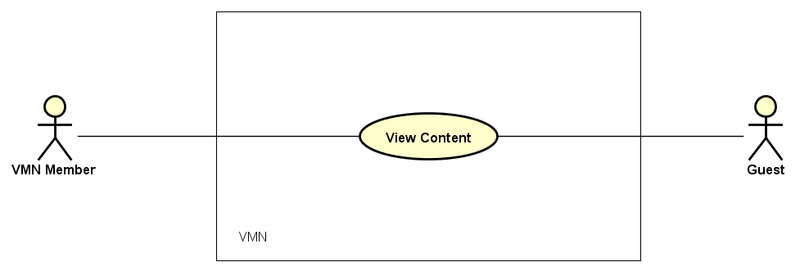
Figure 3-11: View Content use case diagram

Use Case ID |  | UC201 | Use Case Name |  | Authorization
Author |  | Quynh HT | Version | 1.0 | Date | 20/01/2016
Actor |  | VMN Member, Guest
Description |  | The function allows VMN Member and Guest to be able to view article content
Precondition |  | - VMN must be connected to the Internet  - Member browsed VMN website
Trigger
Post-Condition |  | VMN Member and Guest can view article content
Main flows
Step | Actor | Action
1 | Member, Guest | - Type URL into location field of internet browser and then press enter  - On home screen, or click on “Medicinal plant” tab or click on “Remedy” tab.  - Click on “Detail” hypertext of each article’s image
2 | VMN | - Display “Medicinal plant detail” screen if member and guest click on “Medicinal plant” tab:  - Medicinal Plant picture  - Name  - Other name  - Science name  - Description  - Characteristic  - Allocation Place  - Utility  - Rate  - Author  - Remedy Recommendation  - Comment  - Display “Remedy detail” screen if member and guest click on “Remedy” tab:  - Remedy picture  - Title  - Ingredients  - Description  - Usage  - Utility  - Note  - Rate  - Author  - HMS recommendation  - Comment

Alternative flows
AT1 | At step 2 in the main flows, if there is an internal error in the system,
Sub step | Actor | Action
2.1 | VMN | Display "Error" page with message "Internal System Error, please contact with administrator"
AT2 | At step 1 in the main flows, after browser load all of article, member and guest click on an article’s “Detail”, but in this time, the article is deleted.
Sub step | Actor | Action
1 | VMN | Display "Error" page with message "The article is deleted".

Business Rules
# | Rule Description
BR01
BR02

UC202-Basic Search

Screen Design

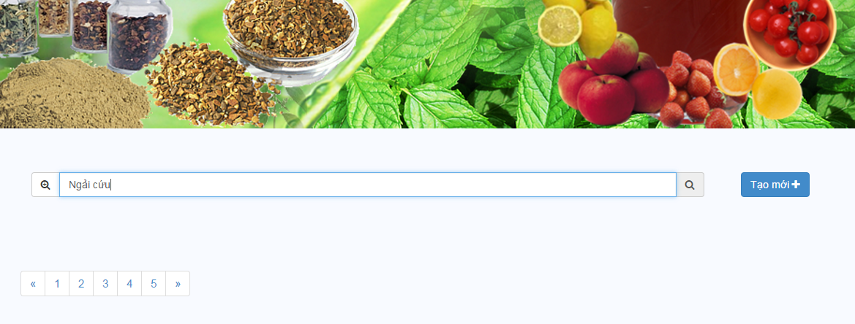
Figure 3-12: Screen design of Basic Search

Table 3-8 Basic Search Screen Definition
# | Field Name | Type | Mandatory | Max Length | Description
1 | Searching | Text field | Yes | 30
2 | Create | Button | Yes
3 | Paging

Use Case Specification

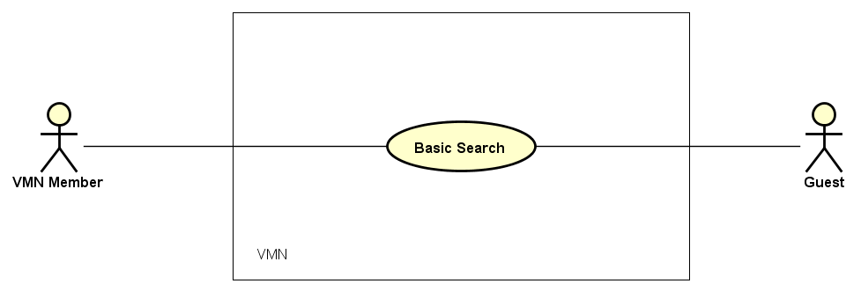
Figure 3-13: Basic Search use case diagram

Use Case ID |  | UC202 | Use Case Name |  | Basic Search
Author |  | QuynhHT | Version | 1.0 | Date | 20/01/2016
Actor |  | VMN Member, Guest
Description |  | The function allows VMN Member and Guest to be able to search an article by name
Precondition |  | - VMN must be connected to the Internet  - Member and Guest browsed VMN website  - Member logged in VMN website
Trigger
Post-Condition
Main flows
Step | Actor | Action
1 | Member, Guest | - Type URL into location field of internet browser and then press enter  - On home screen, or click on “Medicinal plant” tab or click on “Remedy” tab.  - Typing on Searching field.  - Click on “Search” button on the right of Searching field.
2 | VMN | Display result as a list which has suitable keywords.

Alternative flows
AT1 | At step 2 in the main flows, if there is an internal error in the system,
Sub step | Actor | Action
2.1 | VMN | Display "Error" page with message "Internal System Error, please contact with administrator"
AT2 | At step 2 in the main flows, if Member and Guest’s keywords don’t exist in database
Sub step | Actor | Action
2.1 | VMN | Display "Error" page with message "Your keyword that you want to search does not exist in database".

Business Rules
# | Rule Description
BR01
BR02

UC203-Advance Search

Screen Design

Figure 3-14: Screen design of Medicinal Plant Advance Search

Table 3-9: Screen Definition

Table 3-10: Medicinal Plant Advance Search Screen Definition
# | Field Name | Type | Mandatory | Max Length | Description
1 | Medicinal plant name | Text field | Yes | 20
2 | Utility | Text field | No | 50
3 | Description | Text field | No | 50
4 | Characteristic | Text field | No | 50
5 | Allocation place | Text field | No | 30 | The places where medicinal plants grow.
6 | Search | Button
7 | Enter again | Button

Figure 3-1: Screen design of Remedy Advance Search

Table 3-11: Remedy Advance Search Screen Definition
# | Field Name | Type | Mandatory | Max Length | Description
1 | Remedy title | Text field | Yes | 20
2 | Utility | Text field | No | 50
3 | Ingredients | Text field | No | 50
4 | Search | Button
5 | Enter again | Button

Use Case Specification

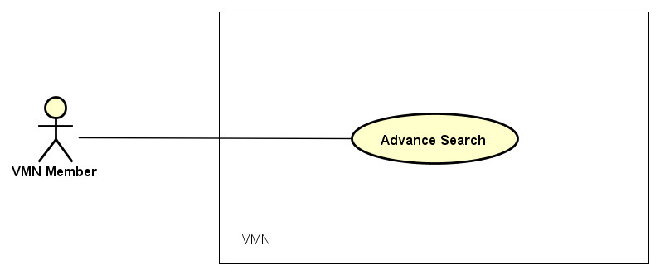

SHAPE \* MERGEFORMAT

Figure 3-15: Use case specification of Advance Search

Use Case ID |  | UC203 | Use Case Name |  | Logout
Author |  | QuynhHT | Version | 1.0 | Date | 20/01/2016
Actor |  | VMN Member
Description |  | The function allows VMN Member to be able to search advance articles by multiple conditions.
Precondition |  | - VMN must be connected to the Internet  - Member browsed VMN website  - Member logged in to system
Trigger
Post-Condition
Main flows
Step | Actor | Action
1 | Member | Click on “Advance Search” icon at the left of “Searching” field on “Medicinal plant” tab or “Remedy” tab.
2 | VMN | - Display Advance Search screen with the following fields if member is being “Medicinal plant” tab :  - Medicinal plant name  - Utility  - Descriptions  - Characteristic  - Allocation place  - Display Advance Search screen with the following fields if member is being “Remedy” tab:  - Remedy title  - Utility  - Ingredients
3 | Member | - Enter keywords to text fields.  - Click on Search button or Enter again button if member want to change keywords then click Search button again.
4 | VMN | Display result as a list which has suitable keywords.

Alternative flows
AT1 | At step 2 in the main flows, if there is an internal error in the system,
Sub step | Actor | Action
2.1 | VMN | Display "Error" page with message "Internal System Error, please contact with administrator"

Business Rules
# | Rule Description
BR01
BR02

UC207- Rate medicinal plants article

Screen Design

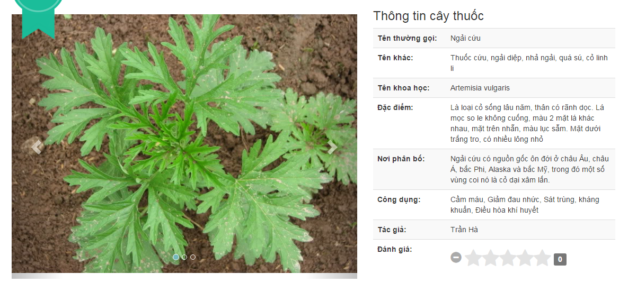
Figure 3-16: Screen Design of Rate medicinal plants article

Table 3-12:Screen Definition
# | Field Name | Type | Mandatory | Max Length | Description
1 | Medicinal plant picture | Image | Yes
2 | Name | Text | Yes | 20
3 | Other name | Text | Yes | 200
4 | Science name | Text | Yes | 40
5 | Description | Text | Yes | 500
6 | Characteristic | Text | Yes | 500
7 | Allocation place | Text | Yes | 100 | The places where medicinal plants grow.
8 | Utility | Text | Yes | 300
9 | Rate |  | Yes |  | Rate from 1 to 5 stars
10 | Author | Text | Yes |  | The person who write the article

Use case specification

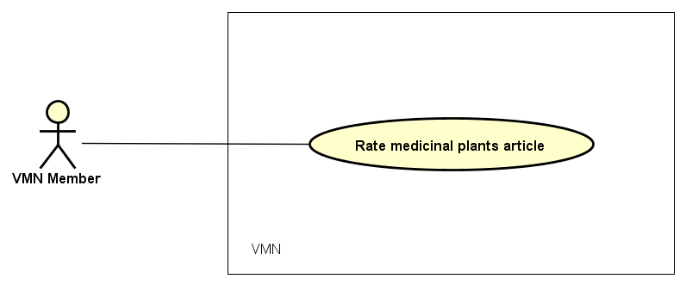
Figure 3-17: Rate medicinal plants article

Use Case ID |  | UC207 | Use Case Name |  | Rate medicinal plants article
Author |  | Quynh HT | Version | 1.0 | Date | 22/01/2016
Actor |  | VMN Member
Description |  | The function allows VMN Member to be able to rate an article.
Precondition |  | - VMN must be connected to the Internet.  - Member browsed VMN website.  - Member logged in VMN website.  - Member are being Medicinal plants article detail screen.
Trigger
Post-Condition
Main flows
Step | Actor | Action
1 | Member | - At Medicinal plants article detail screen, hover mouse on Rate box.  - Click on Rate box
2 | VMN | - Display Rate box as member’s rate.  - “Your rate is send. Thanks for caring” alert is appeared.

Alternative flows
AT1 | At step 2 in the main flows, if there is an internal error in the system,
Sub step | Actor | Action
2.1 | VMN | Display "Error" page with message "Internal System Error, please contact with administrator"
AT2 | At step 2 in the main flows, VMN website cannot received member’s rate.
Sub step | Actor | Action
2.2 | VMN | Display "Error" page with message "Failed to rate this medicinal plants article. Please contract to admin".

Business Rules
# | Rule Description
BR01
BR02

UC208- Rate remedy article

Screen Design

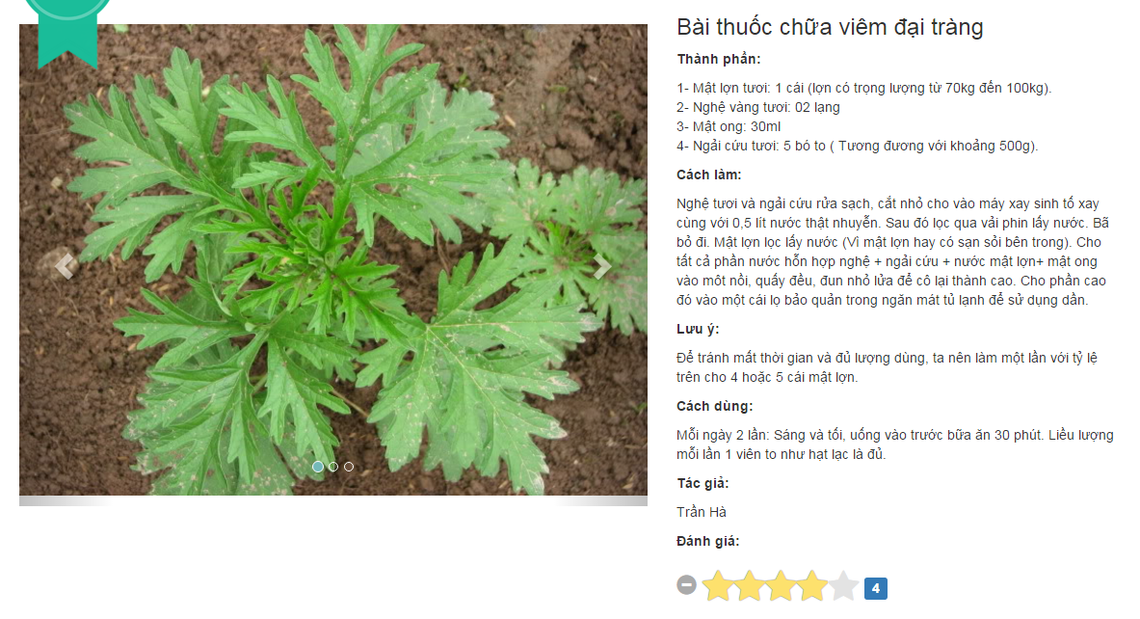
Figure 3-18: Screen design of Rate remedy article

Table 3-13: Screen Definition
# | Field Name | Type | Mandatory | Max Length | Description
1 | Remedy picture | Image | Yes
2 | Title | Text | Yes | 20
3 | Ingredients | Text | Yes | 300
4 | Description | Text | Yes | 500
5 | Usage | Text | Yes | 500
6 | Utility | Text | Yes | 300
7 | Note | Text | Yes | 100
8 | Rate |  | Yes |  | Rate from 1 to 5 stars
9 | Author | Text | Yes |  | The person who share the remedy.

Use case specification

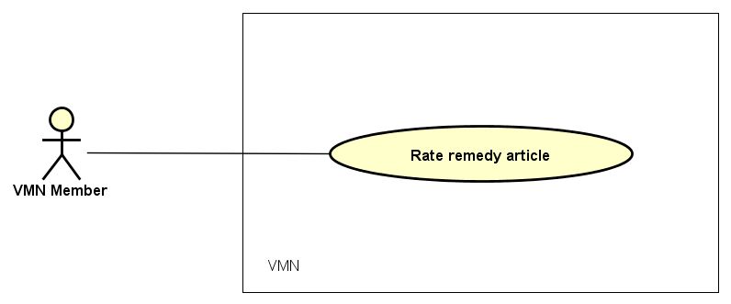
Figure 3-19: Rate remedy article use case diagram

Use Case ID |  | UC208 | Use Case Name |  | Rate remedy article
Author |  | QuynhHT | Version | 1.0 | Date | 22/01/2016
Actor |  | VMN Member
Description |  | The function allows VMN Member to be able to rate an article.
Precondition |  | - VMN must be connected to the Internet.  - Member browsed VMN website.  - Member logged in VMN website.  - Member are being Remedy detail screen.
Trigger
Post-Condition
Main flows
Step | Actor | Action
1 | Member | - At Remedy detail screen, hover mouse on Rate box.  - Click on Rate box
2 | VMN | - Display Rate box as member’s rate.  - “Your rate is send. Thanks for caring” alert is appeared.

Alternative flows
AT1 | At step 2 in the main flows, if there is an internal error in the system,
Sub step | Actor | Action
2.1 | VMN | Display "Error" page with message "Internal System Error, please contact to administrator"
AT2 | At step 2 in the main flows, VMN website cannot received member’s rate.
Sub step | Actor | Action
2.2 | VMN | Display "Error" page with message "Failed to rate this remedy article. Please contact to admin".

Business Rules
# | Rule Description
BR01
BR02

UC211- Approve new medicinal plant article

Screen Design

Use case specification

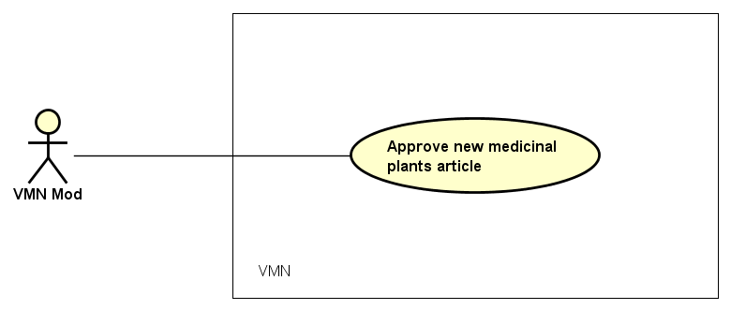
Figure 3-20: Approve new medicinal plants article use case diagram

Use Case ID |  | UC211 | Use Case Name |  | Approve new medicinal plant article
Author |  | Quynh HT | Version | 1.0 | Date | 22/01/2016
Actor |  | VMN Mod
Description |  | The function allows VMN Mod to be able to approve new medicinal plant article which was posted by common member or HMS.
Precondition |  | - VMN must be connected to the Internet.  - Mod browsed VMN website.  - Mod logged in VMN website.
Trigger
Post-Condition
Main flows
Step | Actor | Action
1 | Mod | - Click on Member icon on VMN website header  - Click on Manage medicinal plant article link.
2 | VMN | - Display Manage medicinal plant article screen include following fields:  - Medicinal plants name  - Author  - Create time  - Detail
3 | Mod | Click on Detail button
4 | VMN | Display New medicinal plants article detail screen include following fields:  - Medicinal plant picture  - Name  - Other name  - Science name  - Description  - Characteristic  - Allocation place  - Utility  - Author  - Approve  - Ignore
5 | Mod | - Click on Approve button if satisfied  - If the new medicinal plant article has problem, instead of Approve button, click on Ignore button.
6.1 | VMN | - Save the new medicinal plant article to database and display on VMN website.  - Back to New medicinal plants article detail screen.
6.2 | VMN | Display Complain box alert include following fields:  - Reason that why ignore this medicinal plant article.  - Send
7 | Mod | Enter complain to Complain box then click Send button.
8 | VMN | - Display “Are you sure to send complain to the new medicinal plants article’s author” alert.
9.1 | Mod | Click on OK button to confirm.
9.2 | Mod | Click on Cancel button.
10.1 | VMN | - Send Mod’s complain to the new medicinal plants article’s author.  - Back to New medicinal plants article detail screen.
10.2 | VMN | - Close “Are you sure to send complain to the new medicinal plants article’s author” alert.

Alternative flows
AT1 | At step 2 in the main flows, if there is an internal error in the system,
Sub step | Actor | Action
2.1 | VMN | Display "Error" page with message "Internal System Error, please contact to administrator".
AT2 | At step 6 in the main flows, VMN website cannot save the new medicinal plant article to database.
Sub step | Actor | Action
6.1 | VMN | Display "Error" page with message "Failed to approve the new medicinal plants article. Please contact to admin".

Business Rules
# | Rule Description
BR01
BR02

UC212- Approve new remedy article

Screen Design

Use case specification

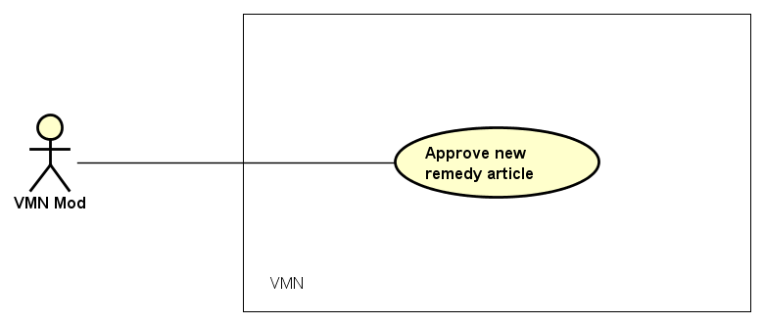
Figure 3-21: Approve new remedy article use case diagram

Use Case ID |  | UC212 | Use Case Name |  | Approve new remedy article
Author |  | Quynh HT | Version | 1.0 | Date | 22/01/2016
Actor |  | VMN Mod
Description |  | The function allows VMN Mod to be able to approve new remedy article which was posted by common member or HMS.
Precondition |  | - VMN must be connected to the Internet.  - Mod browsed VMN website.  - Mod logged in VMN website.
Trigger
Post-Condition
Main flows
Step | Actor | Action
1 | Mod | - Click on Member icon on VMN website header  - Click on Manage remedy article link.
2 | VMN | - Display Manage remedy article screen include following fields:  - Remedy article’s title  - Author  - Create time  - Detail
3 | Mod | Click on Detail button
4 | VMN | Display New remedy article detail screen include following fields:  - Remedy article’s picture  - Title  - Ingredients  - Description  - Usage  - Utility  - Note  - Author  - Approve  - Ignore
5 | Mod | - Click on Approve button if satisfied  - If the new remedy article has problem, instead of Approve button, click on Ignore button.
6.1 | VMN | - Save the new remedy article to database and display on VMN website.  - Back to New remedy article detail screen.
6.2 | VMN | Display Complain box alert include following fields:  - Reason that why ignore this remedy article.  - Send
7 | Mod | Enter complain to Complain box then click Send button.
8 | VMN | - Display “Are you sure to send complain to the new remedy article’s author” alert.
9.1 | Mod | Click on OK button to confirm.
9.2 | Mod | Click on Cancel button
10.1 | VMN | - Send Mod’s complain to the new remedy article’s author.  - Back to New remedy article detail screen.
10.2 | VMN | - Close “Are you sure to send complain to the new remedy article’s author” alert.

Alternative flows
AT1 | At step 2 in the main flows, if there is an internal error in the system,
Sub step | Actor | Action
2.1 | VMN | Display "Error" page with message "Internal System Error, please contact to administrator".
AT2 | At step 6 in the main flows, VMN website cannot save the new remedy article to database.
Sub step | Actor | Action
6.1 | VMN | Display "Error" page with message "Failed to approve the new remedy article. Please contact to admin".

Business Rules
# | Rule Description
BR01
BR02

UC213- Comment medicinal plants article

Screen Design

Use case Specification

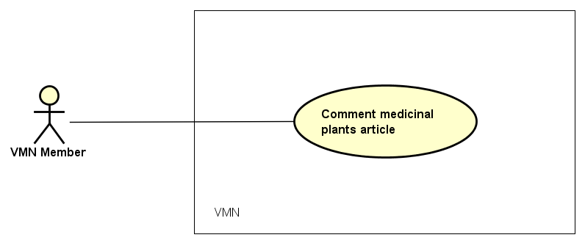
Figure 3-22: Comment medicinal plants article use case diagram

Use Case ID |  | UC213 | Use Case Name |  | Comment medicinal plants article
Author |  | Quynh HT | Version | 1.0 | Date | 22/01/2016
Actor |  | VMN Member
Description |  | The function allows VMN Member to be able to comment a medicinal plants article such as their ideas or their evaluating.
Precondition |  | - VMN must be connected to the Internet.  - Member browsed VMN website.  - Member logged in VMN website successful.
Trigger
Post-Condition
Main flows
Step | Actor | Action
1 | Member | - On Medicinal plants article detail screen, enter comment to Comment text field.  - Click on Post icon at the end of Comment text field.
2 | VMN | - Save the member’s comment into database  - Display the member’s comment and comment’s time on Medicinal plants article detail screen.

Alternative flows
AT1 | At step 2 in the main flows, if VMN website cannot save member’s comment into database
Sub step | Actor | Action
2.1 | VMN | Display "Error" page with message "You cannot comment to the medicinal plants article. Please contact to admin”.

Business Rules
# | Rule Description
BR01
BR02

UC214- Comment remedy article

Screen Design

Use case specification

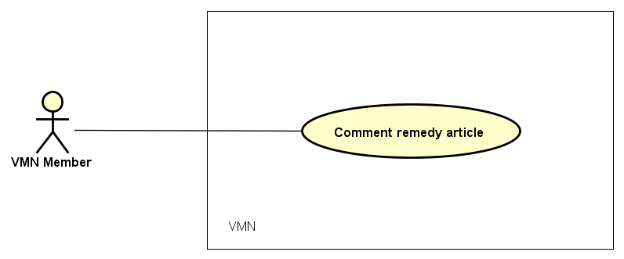
Figure 3-23: Comment remedy article use case diagram

Use Case ID |  | UC214 | Use Case Name |  | Comment remedy article
Author |  | Quynh HT | Version | 1.0 | Date | 22/01/2016
Actor |  | VMN Member
Description |  | The function allows VMN Member to be able to comment a remedy article such as their ideas or their evaluating.
Precondition |  | - VMN must be connected to the Internet.  - Member browsed VMN website.  - Member logged in VMN website successful.
Trigger
Post-Condition
Main flows
Step | Actor | Action
1 | Member | - On Remedy article detail screen, enter comment to Comment text field.  - Click on Post icon at the end of Comment text field.
2 | VMN | - Save the member’s comment into database  - Display the member’s comment and comment’s time on Remedy article detail screen.

Alternative flows
AT1 | At step 2 in the main flows, if VMN website cannot save member’s comment into database
Sub step | Actor | Action
2.1 | VMN | Display "Error" page with message "You cannot comment to the remedy article. Please contact to admin”.

Business Rules
# | Rule Description
BR01
BR02

Member functions

UC301- View member list

Screen Design

Table 3-14: Screen Definition
# | Field Name | Type | Mandatory | Max Length | Description
1 | Search user account and email | Text | Yes | 100
2 | Search | Button | Yes
3 | Account | Text | Yes | 20
4 | Email | Text | Yes | 20
5 | User name | Text | Yes | 20
6 | Member’s role | Text | Yes | 20 | There are 2 roles: member and mode
7 | Detail | Button | Yes
8 | Pagination |  | Yes

Use case specification

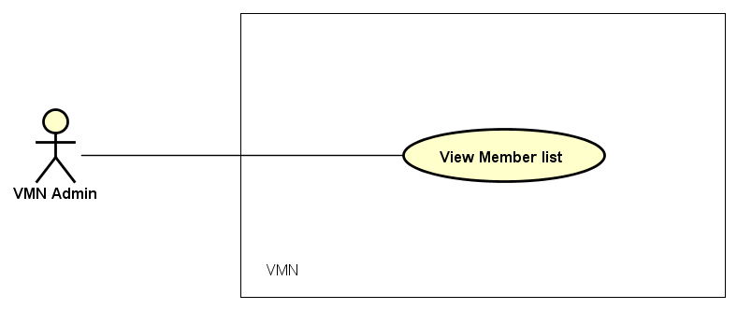

Figure 3-24: Use case specification of View member list

Use Case ID |  |  | UC301 |  | Use Case Name |  | View member list
Author |  |  | DangNH |  | Version | 1.0 | Date | 20/01/2016
Actor |  |  | Admin
Description |  |  | The function allows a administrator to be able to view member list in the software.
Precondition |  |  | - VMN must be connected to the Internet  - Admin logged in VMN system successful
Trigger
Post-Condition
Main flows
Step | Actor |  | Action
1 | Admin |  | - Type URL into location field of internet browser and then press enter  - Click on login button  - Enter right email and password to login admin website.  - On admin website, click on “manage user” tap to show user detail table
2 | VMN |  | Display “View Member List” screen with the following fields:  - Search user account and email  - Search  - Account  - Email  - User name  - Member’s role  - Detail  - Pagination
Alternative flows
AT1 |  | At step 2 in the main flows, if there is an internal error in the system,
Sub step |  | Actor |  | Action
2.1 |  | VMN |  | Display "Error" page with message "Internal System Error, please contact with administrator"

Business Rules
# | Rule Description
BR01
BR02

UC302-Inactive/Active

Screen Design

Table 3-15: Screen Definition
# | Field Name | Type | Mandatory | Max Length | Description
1 | Account | Text | Yes | 20 | Admin cannot edit this information.
2 | Email | Text | Yes | 20 | Admin cannot edit this information.
3 | Member’s name | Text | Yes | 20 | Admin cannot edit this information.
4 | Member’s role | Drop down list | Yes |  | Admin has ability to change member’s role: member becomes mod, mod becomes member. If member’s role is HMS, admin cannot change.
5 | Date of register | Date | Yes |  | Admin cannot edit this information.
6 | Save | Button | Yes |  | After change, admin has to click on this button to update database.
7 | Ban | Button | Yes |  | Admin want to ban an account, he/she will click on this button
8 | Send message | Button | Yes |  | Admin will send a message to member who have been changed about member’s role

Use case specification

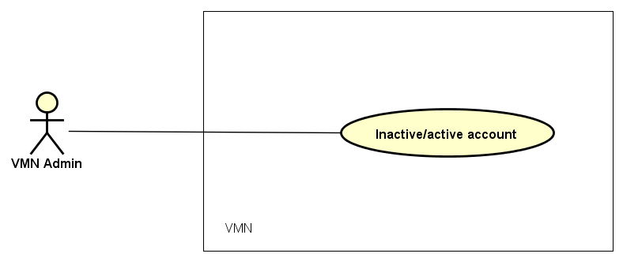

Figure 3-25: Use case diagram of Inactive/active account

Use Case ID |  |  | UC302 |  | Use Case Name |  | Inactive/active account
Author |  |  | DangNH |  | Version | 1.0 | Date | 20/01/2016
Actor |  |  | Admin
Description |  |  | The function allows a administrator to be able to active and inactive member’s account in the software.
Precondition |  |  | - VMN is connected to Internet  - Admin login to VMN website successful
Trigger
Post-Condition
Main flows
Step | Actor |  | Action
1 | Admin |  | On admin’s screen, click on “Manage User” tab.
2 | VMN |  | Display “Manage User” screen:  - “Search user account and email” text field  - “Detail information of member” table:  - Account  - Email  - Member’s name  - Member’s role  - Action  - “Detail” button  - Paging
3 | Admin |  | Click on “Detail” button of “Detail information of member” table
4 | VMN |  | Display “Detail user” modal screen:  - Account  - Email  - Member’s name  - “Member’s role” dropdown list  - Date register  - Save button  - Ban button  - Send message button
5 | Admin |  | Click on “ban” button
6 | VMN |  | Update to database then “Do you want to send a notice message to the member” modal appears.
7 | Admin |  | Click on “Ok” or “No”
8 | VMN |  | Send a notice message to the member who has been banned or active account.
Alternative flows
AT1 |  | At step 2 in the main flows, if there is an internal error in the system,
Sub step |  | Actor |  | Action
2.1 |  | VMN |  | Display "Error" page with message "Internal System Error, please contact with administrator"

Business Rules
# | Rule Description
BR01
BR02

UC304-Update profile

Screen Design

Table 3-16: Screen Definition
# | Field Name | Type | Mandatory | Max Length | Description
1 | Email | Text | Yes | 20
2 | Display name | Text | Yes | 20 | Display "*" instead of clear character
3 | Date of birth | Date | Yes | 20 | Display “day-month-year” form
4 | Gender | Check box | Yes |  | Display 2 choice: Male, Female
5 | Avatar | Image | No
6 | Last name | Text | Yes | 20
7 | First name | Text | Yes | 20
8 | Phone | Text | Yes | 20 | Only number
9 | Address | Text | Yes | 50
10 | Save | Button | Yes

Use case specification

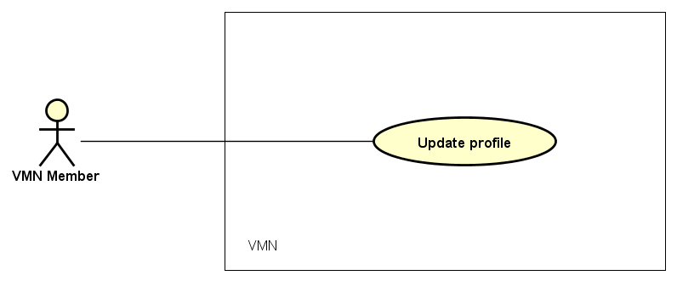

Figure 3-26: Use case specification of Update profile

Use Case ID |  |  | UC304 |  | Use Case Name |  | Update profile
Author |  |  | Dang NH |  | Version | 1.0 | Date | 20/01/2016
Actor |  |  | Member
Description |  |  | The function allows a user to be able to login in the software when he/she have registered an account and his/her account is still active.
Precondition |  |  | - VMN is connected to Internet  - Member browsed VMN website  - Member logged in to VMN website successful
Trigger
Post-Condition
Main flows
Step | Actor |  | Action
1 | Member |  | - Click on Member icon at VMN website’s header  - Click on Member profile link
2 | VMN |  | Display Member profile screen with the following fields:  - Avatar
3 | Member |  | - Enter information change  - Click on Save button
4 | VMN |  | - Save member information change into database.  - Go back to Member profile screen.  - Display member’s update information.
Alternative flows
AT1 |  | At step 2 in the main flows, if there is an internal error in the system,
Sub step |  | Actor |  | Action
2.1 |  | VMN |  | Display "Error" page with message "Internal System Error, please contact with admin"
AT2 |  | At step 4 in the main flow, if VMN website cannot save member information change into database,
4.1 |  | VMN |  | Display “Error” page with message “Cannot update your information, please contact with admin”

Business Rules
# | Rule Description
BR01
BR02

UC305-Change password

Screen Design

Table 3-17: Screen Definition
# | Field Name | Type | Mandatory | Max Length | Description
1 | Email | Text | Yes | 20
2 | Recent password | Password | Yes | 20
3 | New password | Password | Yes | 20
4 | Re-Enter password | Text | Yes | 20 | Re-Enter password must match old password
5 | Save | Button | Yes

Use case specification

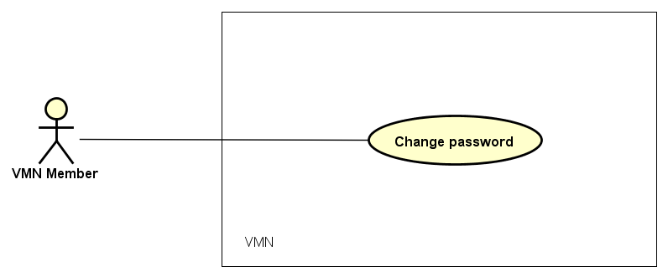
Figure 3-27: Use case specification of Change password

Guest functions

UC401- Register

Screen Design

Use case specification

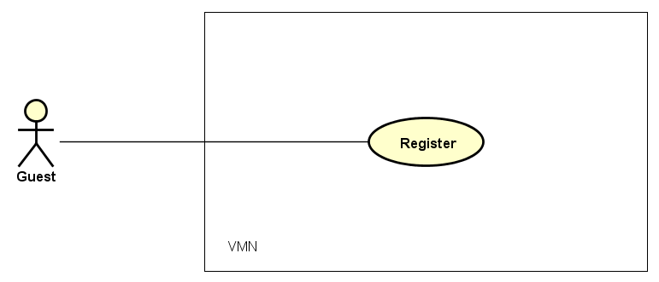
Figure 3-28: Register use case diagram

Use Case ID |  | UC401 | Use Case Name |  | Register
Author |  | Quynh HT | Version | 1.0 | Date | 22/01/2016
Actor |  | Guest
Description |  | The function allows Guest to be able to register and become VMN website’s member.
Precondition |  | - VMN must be connected to the Internet.  - Guest browsed VMN website.
Trigger
Post-Condition
Main flows
Step | Actor | Action
1 | Guest | - On Home screen, click on Register link.
2 | VMN | - Display Register screen by following fields:  - First name  - Last name  - Account  - Email  - Password  - Re-enter password  - Register as HMS  - Register
3 | Guest | - Enter personal information.  - Click on Register button
4 | VMN | - Save guest’s information into database.  - Display message “You registered successfully”.  - Back to Login screen.

Alternative flows
AT1 | At step 2 in the main flows, if there is an internal error in the system,
Sub step | Actor | Action
2.1 | VMN | Display "Error" page with message "Internal System Error, please contact with administrator"
AT2 | At step 3 in the main flows, VMN website cannot save guest’s information into database,
Sub step | Actor | Action
3.1 | VMN | Display "Error" page with message "Failed to register. Please contract to admin".

Business Rules
# | Rule Description
BR01
BR02

Non-Functional Requirements Specification

External Interface Requirements

Member Interfaces
<Describe the logical characteristics of each interface between the software product and the Members. This may include sample screen images, any GUI standards or product family style guides that are to be followed, screen layout constraints, standard buttons and functions (e.g., help) that will appear on every screen, keyboard shortcuts, error message display standards, and so on. Define the software components for which a Member interface is needed. Details of the Member interface design should be documented in a separate Member interface specification.>

Hardware Interfaces
<Describe the logical and physical characteristics of each interface between the software product and the hardware components of the system. This may include the supported device types, the nature of the data and control interactions between the software and the hardware, and communication protocols to be used.>

Software Interfaces
<Describe the connections between this product and other specific software components (name and version), including databases, operating systems, tools, libraries, and integrated commercial components. Identify the data items or messages coming into the system and going out and describe the purpose of each. Describe the services needed and the nature of communications. Refer to documents that describe detailed application programming interface protocols. Identify data that will be shared across software components. If the data sharing mechanism must be implemented in a specific way (for example, use of a global data area in a multitasking operating system), specify this as an implementation constraint.>

Communications Interfaces
<Describe the requirements associated with any communications functions required by this product, including e-mail, web browser, network server communications protocols, electronic forms, and so on. Define any pertinent message formatting. Identify any communication standards that will be used, such as FTP or HTTP. Specify any communication security or encryption issues, data transfer rates, and synchronization mechanisms.>

Other Nonfunctional Requirements

Performance Requirements
<If there are performance requirements for the product under various circumstances, state them here and explain their rationale, to help the developers understand the intent and make suitable design choices. Specify the timing relationships for real time systems. Make such requirements as specific as possible. You may need to state performance requirements for individual functional requirements or features.

This section lists all requirements whose Category has been stated in the goal model to be ‘performance’>

Design constraints
<This section lists all requirements whose Category has been stated in the goal model to be ‘development’ or ‘architecture’ (see Figure 7.5)

Safety Requirements
<Specify those requirements that are concerned with possible loss, damage, or harm that could result from the use of the product. Define any safeguards or actions that must be taken, as well as actions that must be prevented. Refer to any external policies or regulations that state safety issues that affect the product’s design or use. Define any safety certifications that must be satisfied.

This section lists all requirements whose Category has another value e.g. ‘safety’

>

Security Requirements
<Specify any requirements regarding security or privacy issues surrounding use of the product or protection of the data used or created by the product. Define any Member identity authentication requirements. Refer to any external policies or regulations containing security issues that affect the product. Define any security or privacy certifications that must be satisfied.>

Software Quality Attributes
<Specify any additional quality characteristics for the product that will be important to either the customers or the developers. Some to consider are: adaptability, availability, correctness, flexibility, interoperability, maintainability, portability, reliability, reusability, robustness, testability, and usability. Write these to be specific, quantitative, and verifiable when possible. At the least, clarify the relative preferences for various attributes, such as ease of use over ease of learning.

This section lists all requirements whose Category has another value e.g. ‘accuracy’ >

